“Bienvenu” Event Management System

Phase 1 – Planning and Architecture Design

Group Members
- Ayush Thakur (N01649393)
- Manas Pandya (N01657298)
- Vivek Chalodiya (N01652717)

1. Business Case
In educational institutions or local communities, managing events like workshops, webinars, and hackathons is often done manually or through unstructured tools.
This results in poor coordination, missed schedules, and low engagement.
The project “Bienvenu”, an Event Management System (EMS) provides a platform for users to browse and register for events and for organizers to create and manage events.
It includes event listings, filters, notifications, and secure role-based access. This solution streamlines event participation and administration.

2. Target Audience
- Students and professionals who want to attend events.
- Event organizers who need a platform to manage registrations and details.
- Venue property managers who want to advertise their venues.
- Event organizations who need a tool to manage

3. Proposed Solution
A responsive web application allowing:
- User registration and authentication.
- Event creation, updating, and deletion by organizers.
- Viewing, searching, and registering for events by users.
- Notification upon successful registration.
- REST API support with documentation via Swagger.

4. Scope
Core Functionalities (MVP):
- Secure login and registration (Spring Security)
- CRUD operations for events
- Event registration functionality
- RESTful APIs and Swagger documentation
Optional Features (Phase 2 and 3):
- Email notifications using JavaMail
- Search and filter by category/date
- Join event links via email

5. Justification
This project addresses common event coordination problems and is suitable for real-world deployment.
It provides hands-on experience in backend/frontend development, API creation, Spring Security, containerized deployment, and testing.

Task Distribution
- Ayush Thakur – EJB Container
- Manas Pandya – Web Component
- Vivek Chalodiya – Database connection

6. Test Cases
Functional Test Cases:
- TC-F01: User successfully registers for an event.
- TC-F02: Admin creates a new event and it appears in listing.
- TC-F03: Invalid event registration (past date) is blocked.
- TC-F04: Only logged-in users can register for events.
- TC-F05: REST API returns all events correctly in JSON.
Integration Test Cases:
- TC-I01: End-to-end test: register for event → data saved in DB.
- TC-I02: Admin deletes an event → users can no longer see it.
Boundary Test Cases:
- TC-B01: Try to register for a full event → show 'full' error.
Error Handling Test Cases:
- TC-E01: DB failure during registration → error handled gracefully.

7. UML Diagrams (Class)
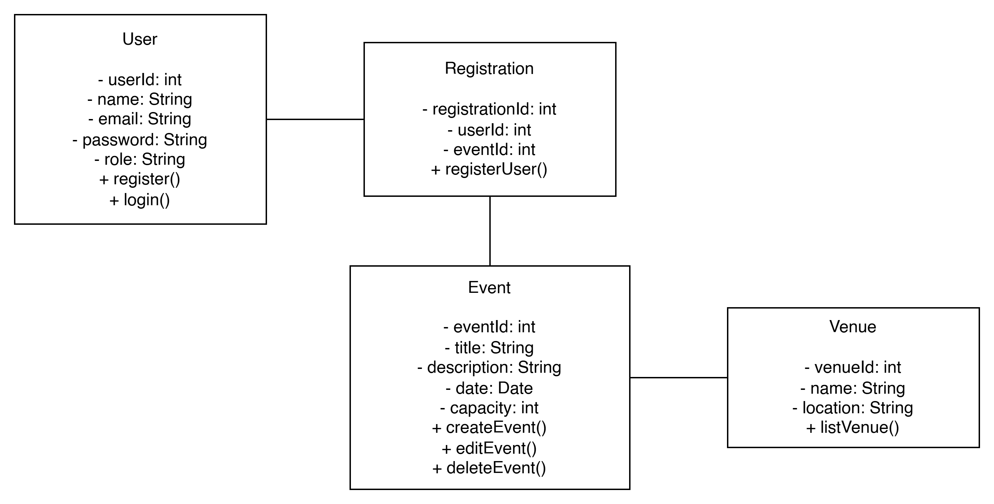

8. UML Diagrams (Sequence)
